Day 27 – Version Control

Demonstrate Version Control – Assignment 1

1. Create a Spring application and push it to Github by creating a new repository.

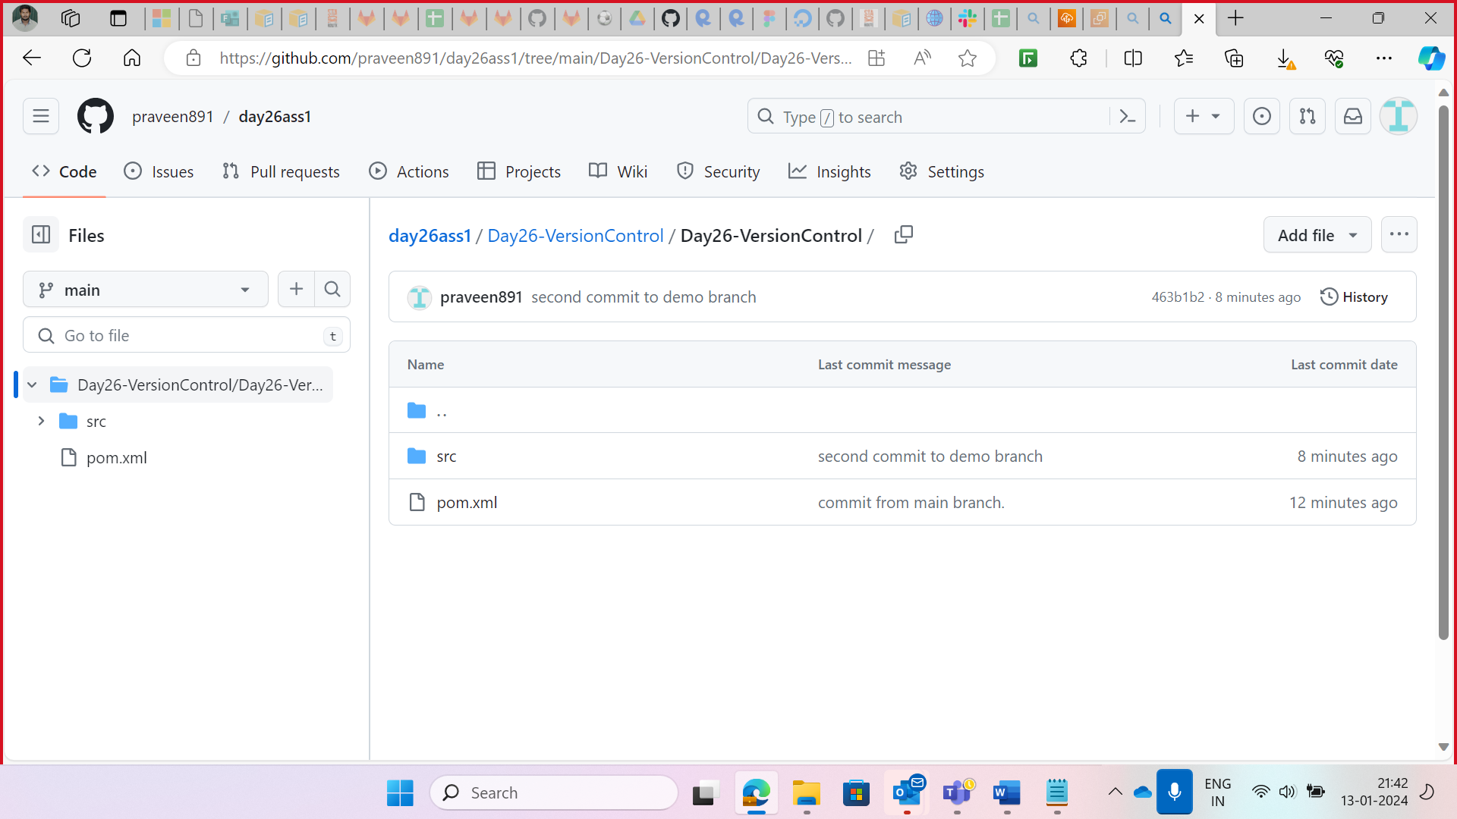

1. Make changes in the code and push it from a different branch

1. You will get a Pull request in the Github. As shown in the below figure,
2. Click on Compare & pull request

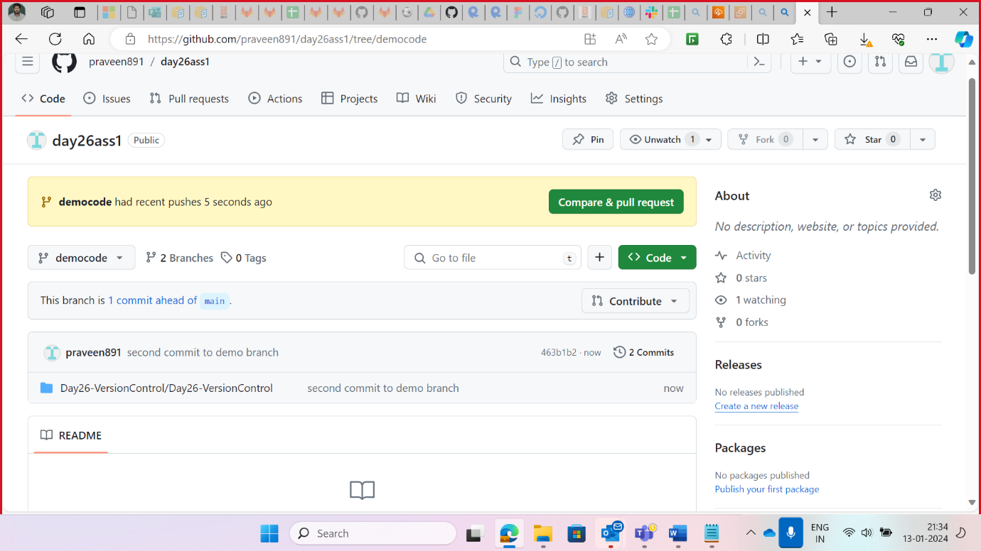

1. Add Comments and description accordingly.

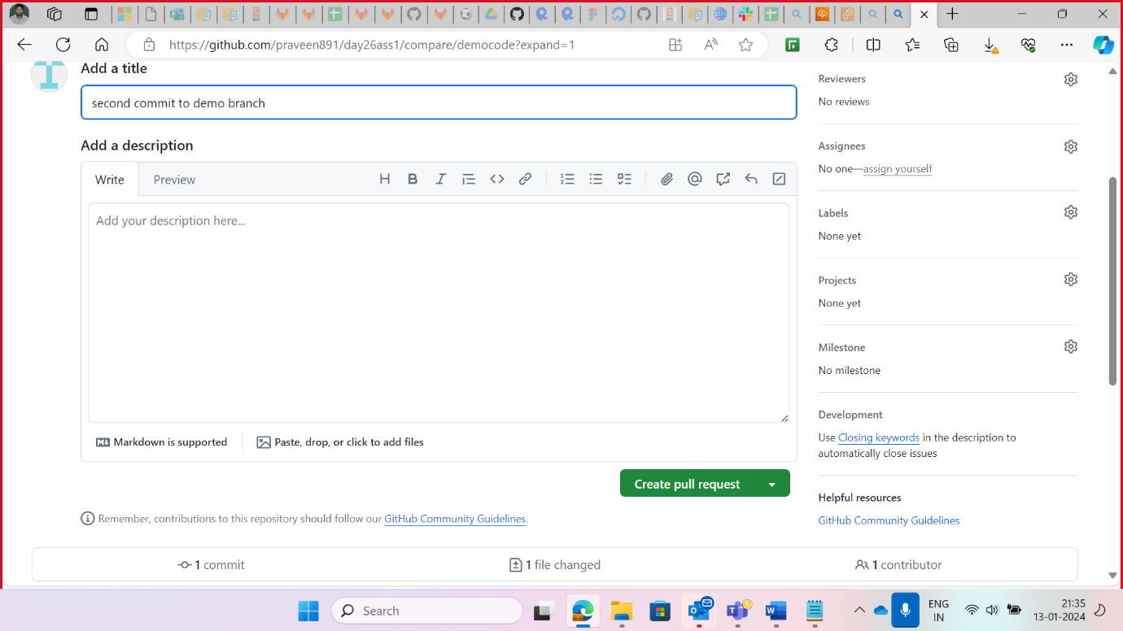

1. Click on Merge Request and comments.



